***The World Islamic Science and Education University***

جامعة العلوم الاسلامية العالمية

Faculty of Information Technology

كلية تكنولوجيا المعلومات



GRADUATION PROJECT

**Title**:

*E-practical training*

**Students**:

|  |  |
| --- | --- |
| Mohammad Abdallah | 3180605071 |
| Ali Alqawasmeh | 3180601046 |

**Supervisor**: Mr. Hasan Abualese

Semester II

2021/2022

**Acknowledgments**

A very hart warming gratitude to all of those who helped us reach this day, without them we would not be here.

We would like to thank our university for the help and knowledge we got

and especially our supervisor Hasan Abualese for his heartwarming motivation and guidance in the process of making this project.

We also would like to dedicate this work to our loving families and friends, there were always with us from the start of our journey.

**Abstract**

The problem with practical training is that it is routine work where the student must go to the university to fill out an application and then go to the company for approval and then return to the university again to complete the procedures. Our project completes this problem, as we have converted it into an electronic procedure where the student can submit and start the procedures from his home without having to go anywhere.

Table of Contents

Chapter 1: Introduction………………………………………………………………………………………………….6

1.1. Overview……………………………………………………………………………………………………………6

1.2. Problem statement…………………………………………………………………………………………………..6

1.3. Project objectives……………………………………………………………………………………………...……6

1.4. Research strategy……………………………………………………………………………………………..…….6

1.5. Gantt chart…………………………………………………………………………………………………………8

1.6. Project outline…………………………………………………………………………………………………..…9

Chapter 2: Literature review …………………………………………………………………………………………..10

2.1. Overview…………………………………………………………………………………………………………..10

2.2. Related work……………………………………………………………………………………………………....10/11

**Chapter 3: Methodology…………………………………………………………………………………………….….11**

3.1. Overview…………………………………………………………………………………………………………………………………………………………..11

3.2. Feasibility study……………………………………………………………………………………………...……11

3.3. Requirements and tools……………………………………………………………………………………………12

3.3.1. Functional requirements……………………………………………………………………………..…….12

3.3.2. Non-Functional requirements……………………………………………………………………………..13

3.3.3. Tools used…………………………………………………………………………………………………13

3.4. Methodology process……………………………………………………………………………………...………14

**Chapter 4: Design Models………………………………………………………………………………………...…….16**

4.1. Overview…………………………………………………………………………………………………...………16

4.2. Context diagram…………………………………………………………………………………………..………..16

4.3. Use case diagram………………………………………………………………………………………..………….17

4.4. Dataflow diagram……………………………………………………………………………………..……………18

4.4. Entity-relationship diagram…………………………………………………………………………...……………19

**Chapter 5: Experiments and results……………………………………………………………………..……………..20**

5.1. Overview……………………………………………………………………………………………...……………20

5.2. Testing methodologies………………………………………………………………………………...……………20

5.2.1. Unit Testing……………………………………………………………………………………..…………20

5.2.2. Integration Testing……………………………………………………………………………...………….35

5.2.3. System Testing…………………………………………………………………………………..…………38

**Chapter 6: Conclusion…………………………………………………………………………………………………...39**

6.1. Conclusion………………………………………………………………………………………………………….39

6.2. Future work…………………………………………………………………………………………………………39

References…………………………………………………………………………………………………………………40

Appendix…………………………………………………………………………………………………………………..41

**List of tables**

Table 1: Gant chart………………………………………………………………………………………………………8

Table 2: Related work comparison………………………………………………………………………………............11

**List of figures**

Figure 1: Agile methodology……………………………………………………………………………………………...7

Figure 2: Kanban board…………………………………………………………………………………………….…….15

Figure 3: Context diagram………………………………………………………………………………………….…….16

Figure 4: Use case diagram………………………………………………………………………………….……..…..…17

Figure 5: Dataflow diagram………………………………………………………………………………….…………..18

Figure 6: Er diagram…………………………………………………………………………………………..…...……..19

Figure 7: Home page with log in …………………………………………………………………………….….………21

Figure 8: Error message……………………….…………………………………………………………………………21

Figure 9: student page ……………………………………………………………………………………….…………..22

Figure 10: student page 2 ……………………………………………………………………………………………….23

Figure 11: Available companies….……………………………………………………………………………………….24

Figure 12: Search engine……………………………………………………………………………………………….....25

Figure 13: Filter page…………….……………………………………………………………………………………….26

Figure 14: Search using filter…………………………………………………………………………………………….27

Figure 15: Training Request……..…………………………………………………………………………………….…27

Figure 16: Training Request 2………………………………………………………………………………………...…..28

Figure 17: Full all input ………………………… ………………………………………………………………………29

Figure 18: Company Database……………………………………………………………………………………………29

Figure 19: Send Approval………………………………………………………………………………………………...30

Figure 20: Students accept database……………………………………………………………………………………...30

Figure 21: Company offers…………………………………………………………………………………………….…31

Figure 22: Admin site 1. …………………………...…………………………………………………………………..…32

Figure 23: Company offers admin site.…………….…………………………………………………………………..…33

Figure 24: Available company.……………………………………………………………………………………………33

Figure 25: Edit the company.…………………………………………………………………………………………..…34

Figure 26: Student acceptance. …..……………………………………………………...……………………………..…34

Figure 27: Test case …………………………………………………………………………………………………..…35

Figure 28: Bug report…………………………………………………………………………………………………..…36

**Chapter 1: Introduction**

1. Overview.

This chapter will be going through the problems that initiated the need for this project, the project’s desired objectives to be met by the end of this project, the framework used in building this project, a Gant chart, and a project outline.

2. Problems statement.

1. The problem of routine procedures in submitting the application, where the student must go to more than one place to be able to apply and is a problem for the student.
2. Some students face a problem in finding a training company for them, as problems may occur because of this in terms of delay in training.
3. The electronic field where the paper-based procedures must be converted to electronic to develop the university community.

3. Project objectives.

1. Create a platform in a portal for students who will do practical training that will show them their portal.
2. Build an easy-to-use graphic user interface for students that allows them to search for companies they want to train in specific fields or specializations or by their specific names.
3. Create a platform for the administrator, who determines the names of students who have been accepted and receive the confidential evaluation and other tasks.

4. Research strategy.

We’ve decided to use the agile methodology as well as using the Kanban board method in this project due to these reasons:

1. Agile works well with shorter turnaround times and tight deadlines, and the duration given for this project is fairly short.
2. Unclear requirements and the possibility of a change, agile methodologies work well when the project has few initial requirements and doesn’t need to meet strict regulations.
3. The possibility of working on some specifications only without the need to complete all specifications through the sprint system, as it is based on the establishment of a meeting to search for specifications.

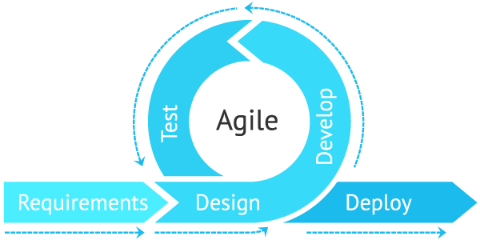

*Figure 1: Agile methodology*

5. Gantt chart.

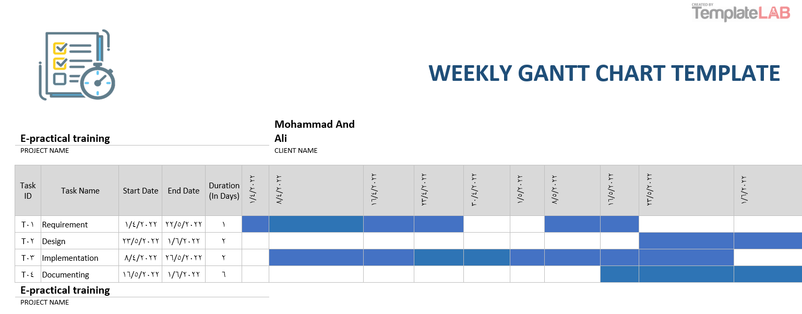

*Table 1: Gant chart*

6. Project outline.

Chapter 1: Introduction.

This chapter explains the project’s purpose by stating the problems that need to be solved, the project’s objectives, the research strategy, the Gantt chart, and this project outline.

Chapter 2: A literature review.

In this chapter, we will learn about some examples and practical applications of the project from other universities and provide a theoretical description of the project.

Chapter 3: Methodology.

This chapter goes through the feasibility study for this project and the methodologies used, the functional and non-functional requirements, as well as the tools used in developing this project.

Chapter 4: Design Models.

This chapter demonstrates how the system works by showing a set of diagrams.

Chapter 5: Experiments and results.

This chapter goes through the processes that happened during the implementation and testing of the project.

Chapter 6: Conclusion.

A quick summary of the project and the plans for future works.

**Chapter 2:** **Literature review**

1. Overview.

In this chapter, we will be going through some related works in this field and discussing their limitations and what we think this project will provide that other works don’t have.

2. Related Work.

The following are some of the regulations in force in some Jordanian universities in this field with mentioning the name of the university:

1. The Hashemite University

Hashemite University implements its electronic training system, where the student in the College of Engineering can apply electronically, and then the university communicates between the student and the company.

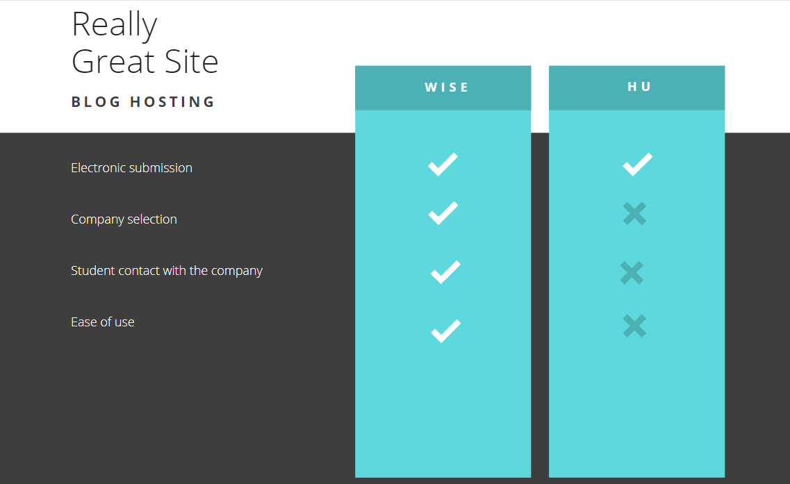

*Table 2: Related work comparison*

**Chapter 3: Methodology**

1. Overview.

In this chapter, we’ll go through the methodologies and tools used to develop this project.

From the feasibility study followed by the functional and non-functional requirements and the tools used, to the data collecting methods used.

2. Feasibility study.

1. Technical feasibility.

The project provides training opportunities for students who do not know what company or the type of training they want and also saves time as they do not need to go to the university for routine procedures.

2. Economic feasibility.

The site enables the student to facilitate the application for companies, as he does not need to go to the university and then to the company to submit a training application, as it saves time and effort for the student.

3. Operational feasibility.

The operation of the site will not affect the occurrence of problems for the university or companies, as it saves time and effort and organizes matters between the university and companies in terms of the number of students and greater cooperation may occur between the two parties.

3. Requirements and tools.

In this section, the requirements will be divided into functional and non-functional requirements.

1. Functional requirements.

The admin must have access to the following functions:

* Log in to the approved profile
* Approval or rejection of the proposed companies
* The possibility of modifying or deleting a company
* Receiving approval requests from students
* Sign out

The student should have access to these functions:

* Log in to the student portal
* Choose the company and type of training
* Submit a training request to the company
* Send an approval file to the administrator
* Sign out

The company should have access to these functions:

* Submit a training offer to the university
* Show training information to the student
* Approval or refusal to train the student
* Storing student data on the company's database
* Send the training approval to the student by e-mail

2. Non-Functional requirements.

* **Security**

Each user (student) has a user name and a private password that is stored in the university database and is protected so that no one can access it and each user (administrator) has a job number and a protected password.

The server is protected in the same way that the university website is protected.

* **User friendly and simplicity**

Simple design interface with ease of navigation, ease of choosing the company, ease of applying, and sending the approved file to the university.

* **Ease of use**

The website is simple to use with straightforward functionality.

3. Tools used.

The tools that are used in developing this website are:

* Visual studio code (code editor)
* PHP (backend language)
* MySQL (relational database management system ‘RDBMS’)
* XAMPP (locale server)
* HTML, CSS, JavaScript (frontend formatting languages)
* GitHub (code hosting platform)
* Discord (communication tool)
* Draw.io diagram
* Bootstrap 4
* canva

4. Methodology process.

This project is using the agile methodology and the Kanban method for building the E-practical training system.

Advantages of Kanban:

1. It’s focused on continuous delivery.
2. Kanban is easy to understanding methodology.
3. It reduces the time cycle of the process.

This table represents the Kanban board at one point during the development of this project:

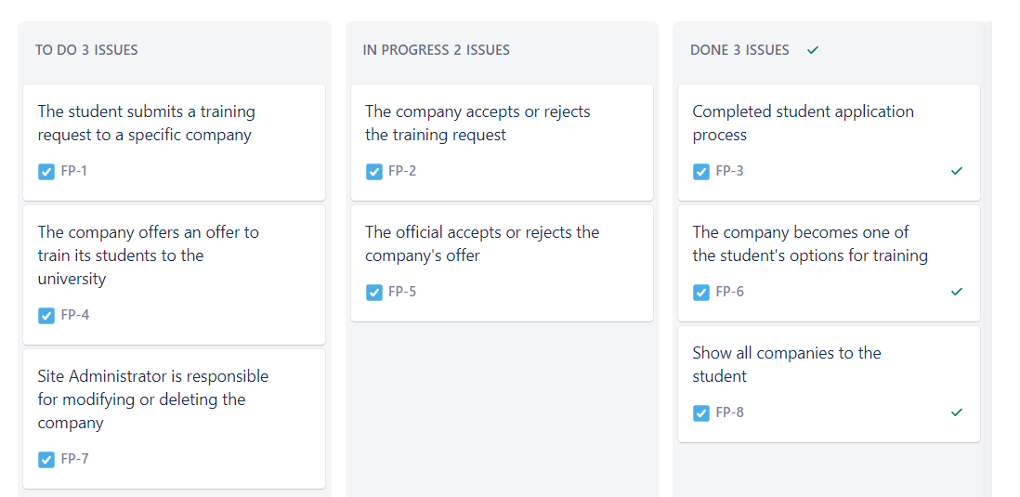

*Figure 2: Kanban board*

**Chapter 4:** **Design Models**

1. Overview.

This chapter will contain the design diagrams that represent this system, including a context diagram, use case diagram, data flow diagrams, and an ER diagram.

2. Context diagram.

This is a context-level data flow diagram (level 0) that shows the main users of the system as well as the way that they’re going to be interacting with the system.  
  
The system has 3 types of users: patients, doctors, and admins.  
And each of them interacts with the system as shown in the diagram below.

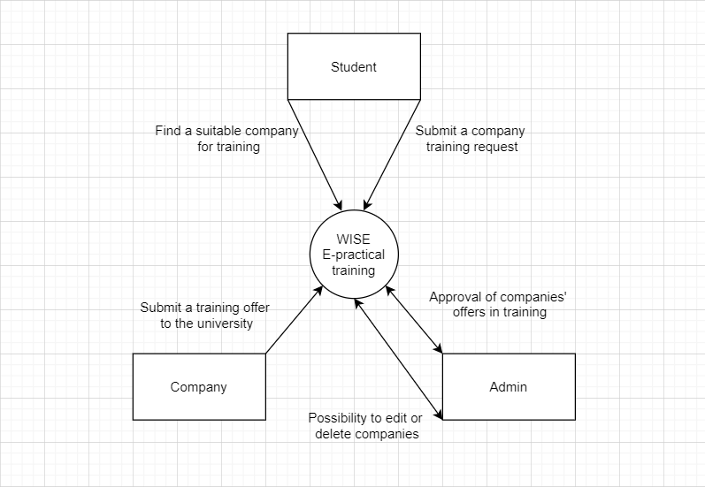

*Figure 3: Context diagram*

3. Use a case diagram.

With the use case diagram, we can identify the three types of actors and the functions (use cases) that the system must provide for these actors.

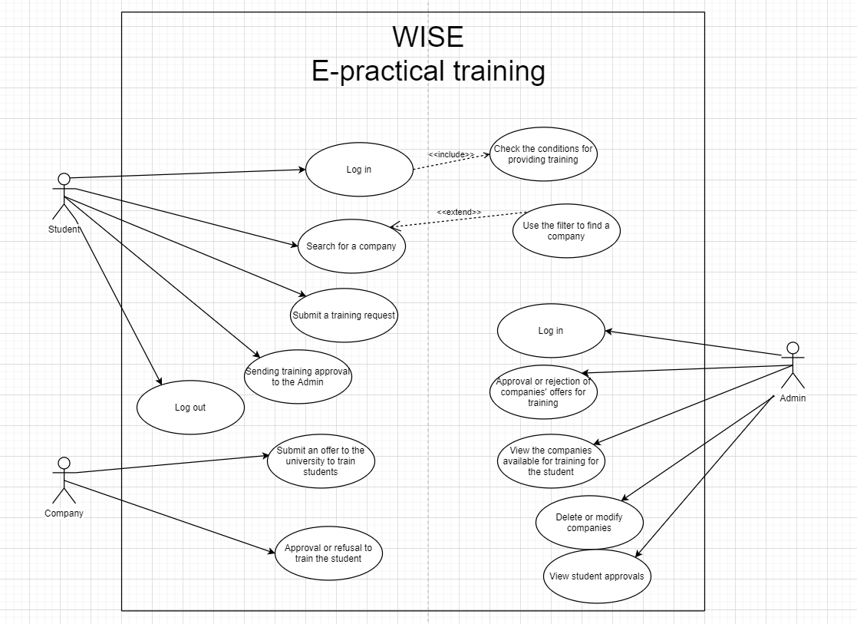

*Figure 4: Use a case diagram*

4. Dataflow diagram.

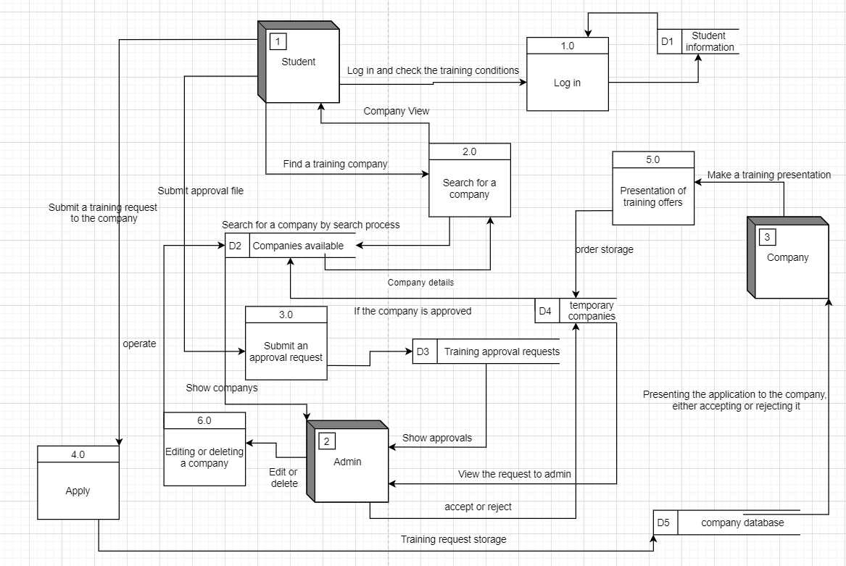

*Figure 5: Dataflow diagram*

5. Entity relationship diagram.

The ER diagram shows us the entity types in the database which are the students, companies, and the admin.

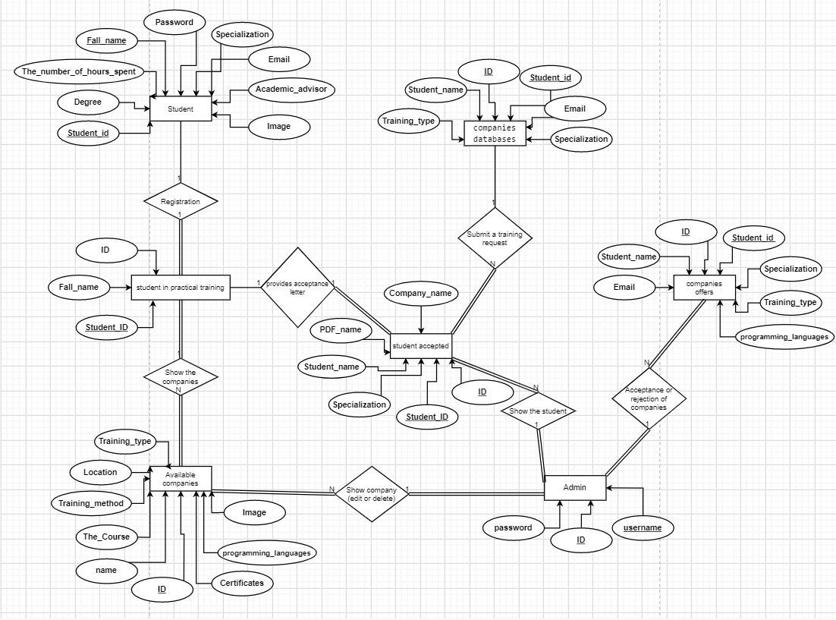

*Figure 6: Er diagram*

**Chapter 5:** **Experiments and results**

1. Overview.

In this chapter, we did some testing on the system to ensure that all functions meet the requirements, and we documented all the results and our test cases.

2. Testing methodologies.

1. Unit Testing.

1-1. Log in student.

On the main page, the student logs in with his university number and password.

1. Verify the username and password, and if they are not correct, an error will be given. (Number 1)

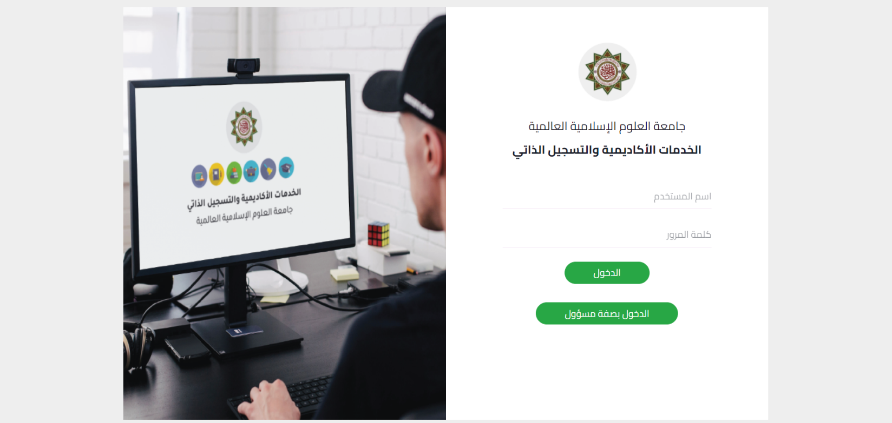

*Figure 7: Home page with login*

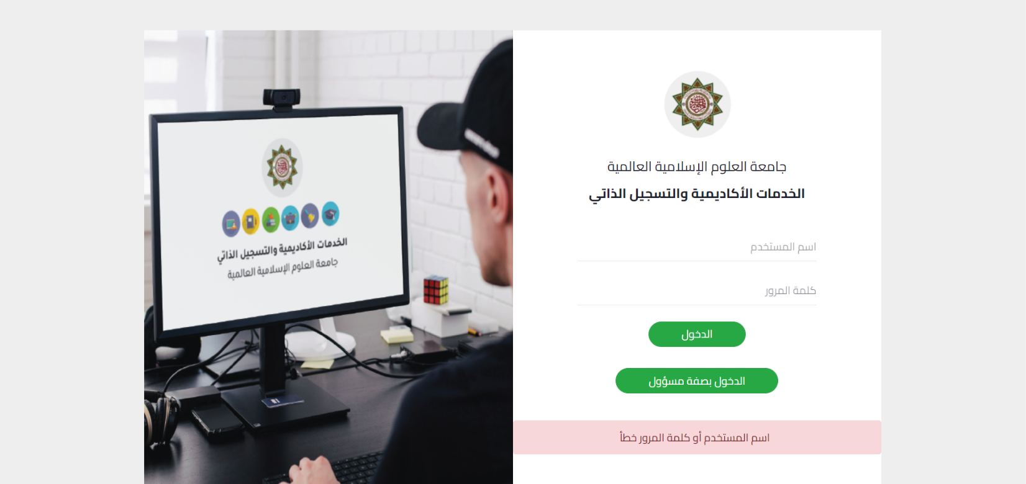

1

*Figure 8: Error message*

1-2. Check training conditions.

After entering the student, two conditions are confirmed in the student database:

1- It exceeds 90 hours.

1. To be registered in practical training.

If both conditions are met, it will activate the button.

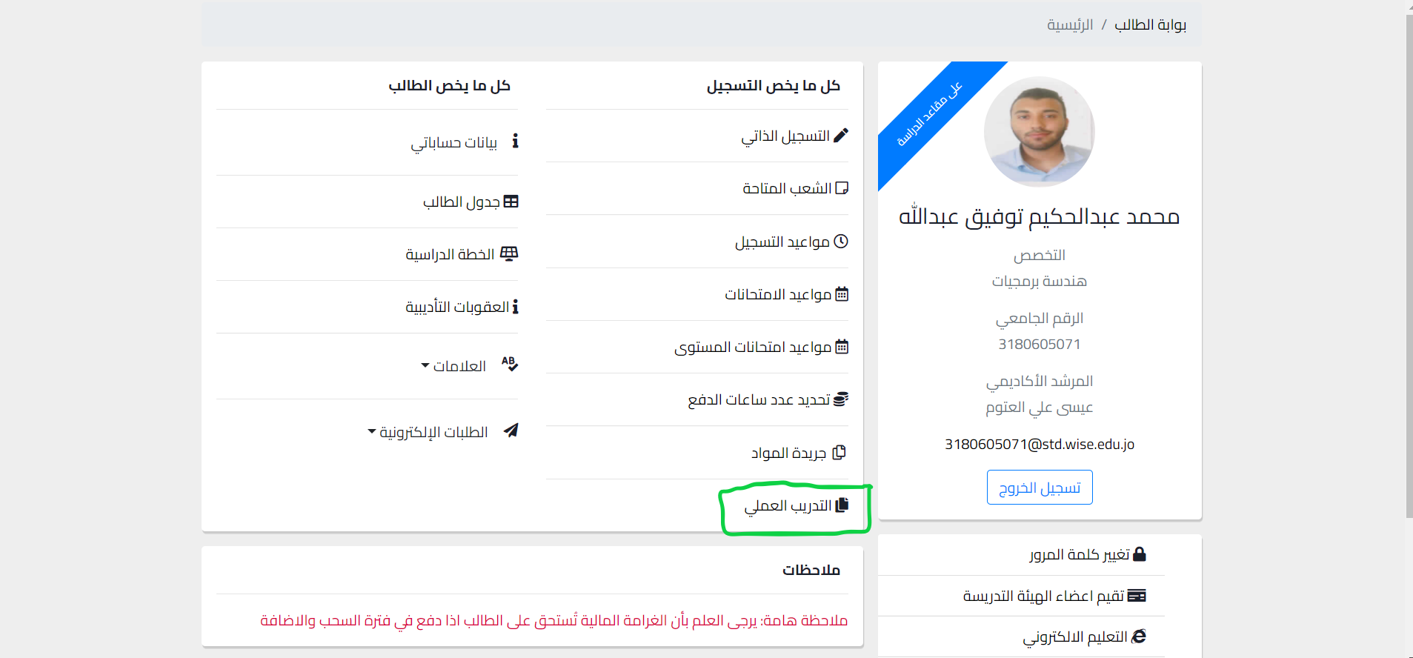

*Figure 9: student page*

If the two conditions are not met, it will not be activated

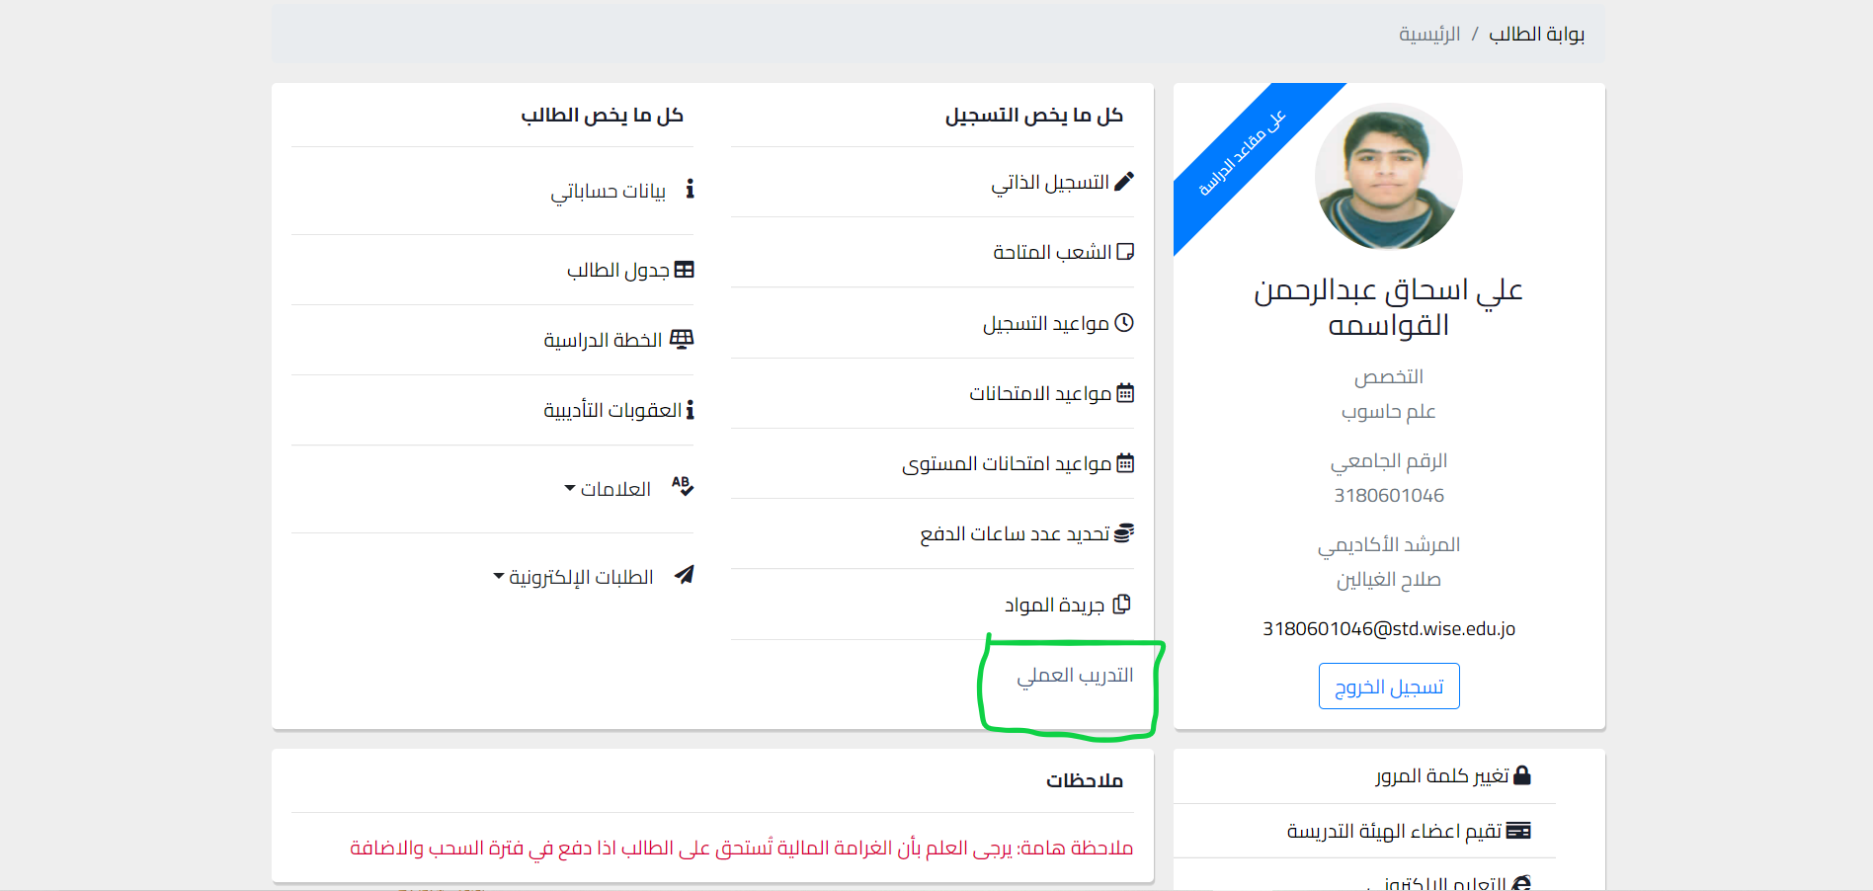

*Figure 10: student page 2*

1-3. After verifying the conditions, the student enters the site.



*Figure 11: First page*

-If the student chooses number one (1)، all companies available for training will be displayed with the possibility of searching for the name of the company or a specific type of training.

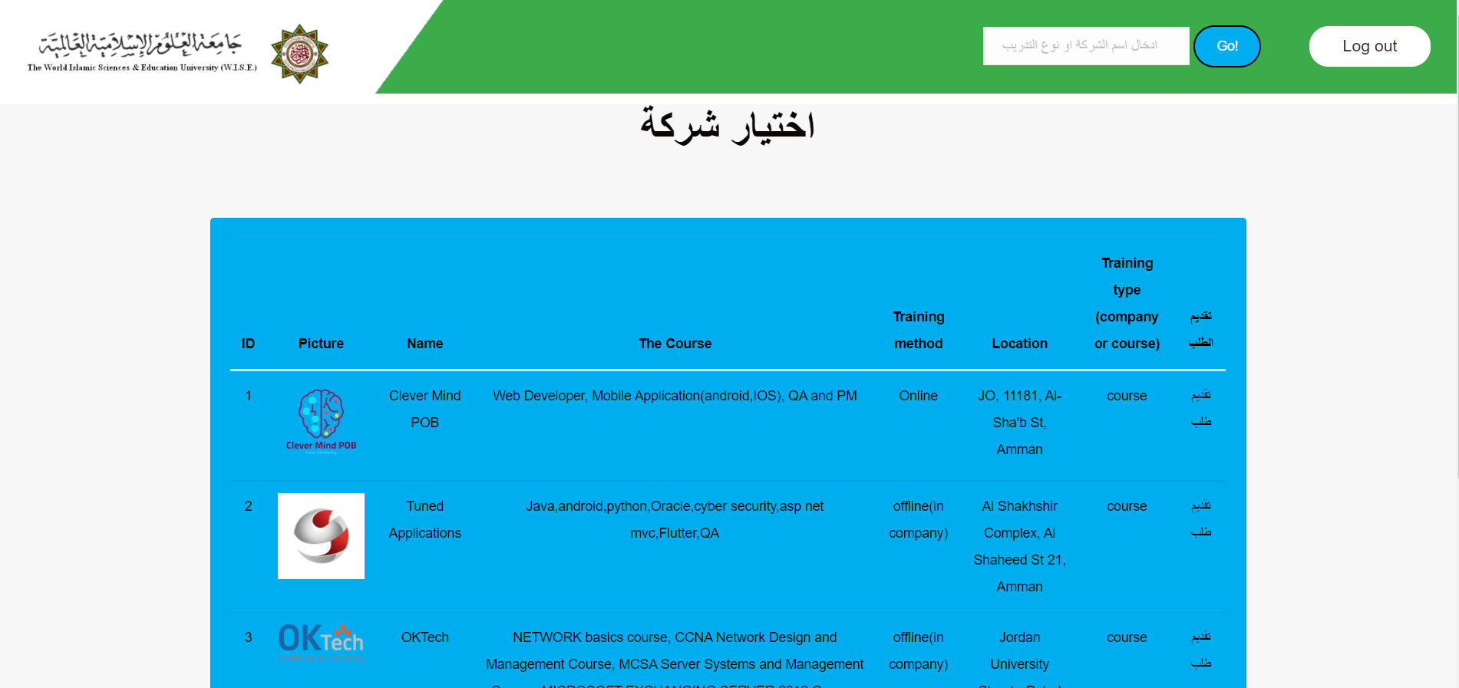

*Figure 12: Available companies*

-The student searches for the name of the company or the type of training through the search engine.

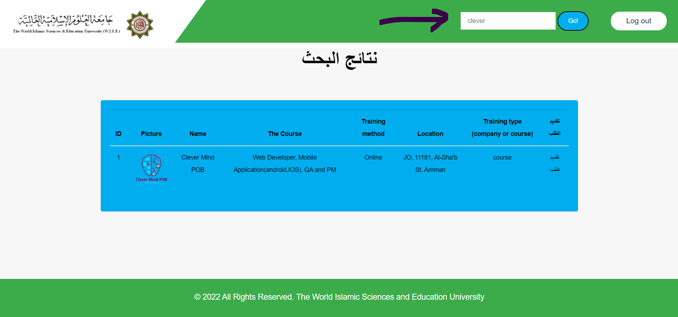

*Figure 13: Search engine*

- If the student chooses number two, a help page for searching for a company will be shown if the student does not know the type of training he wants.

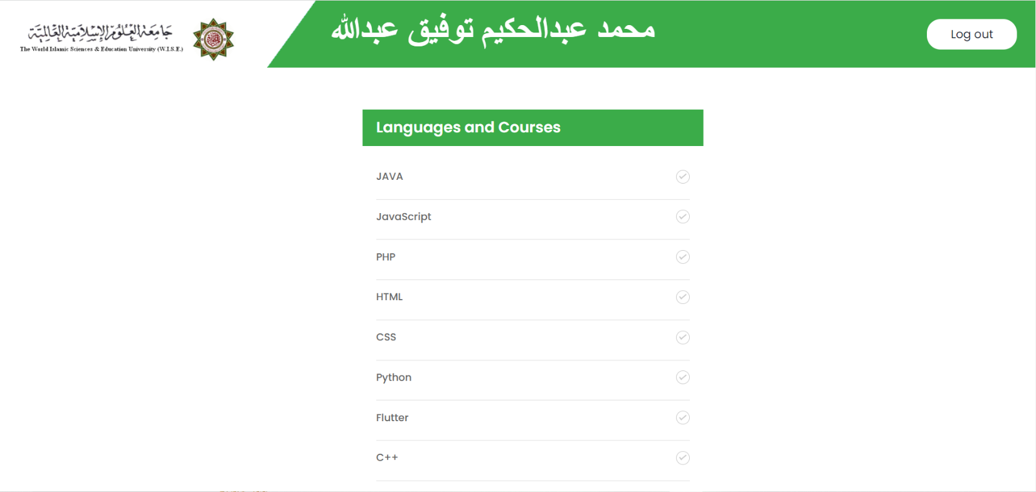

*Figure 14: Filter page*

- The student chooses the programming languages he knows or the courses he owns, where companies are suggested that contain the languages or courses the student has entered.

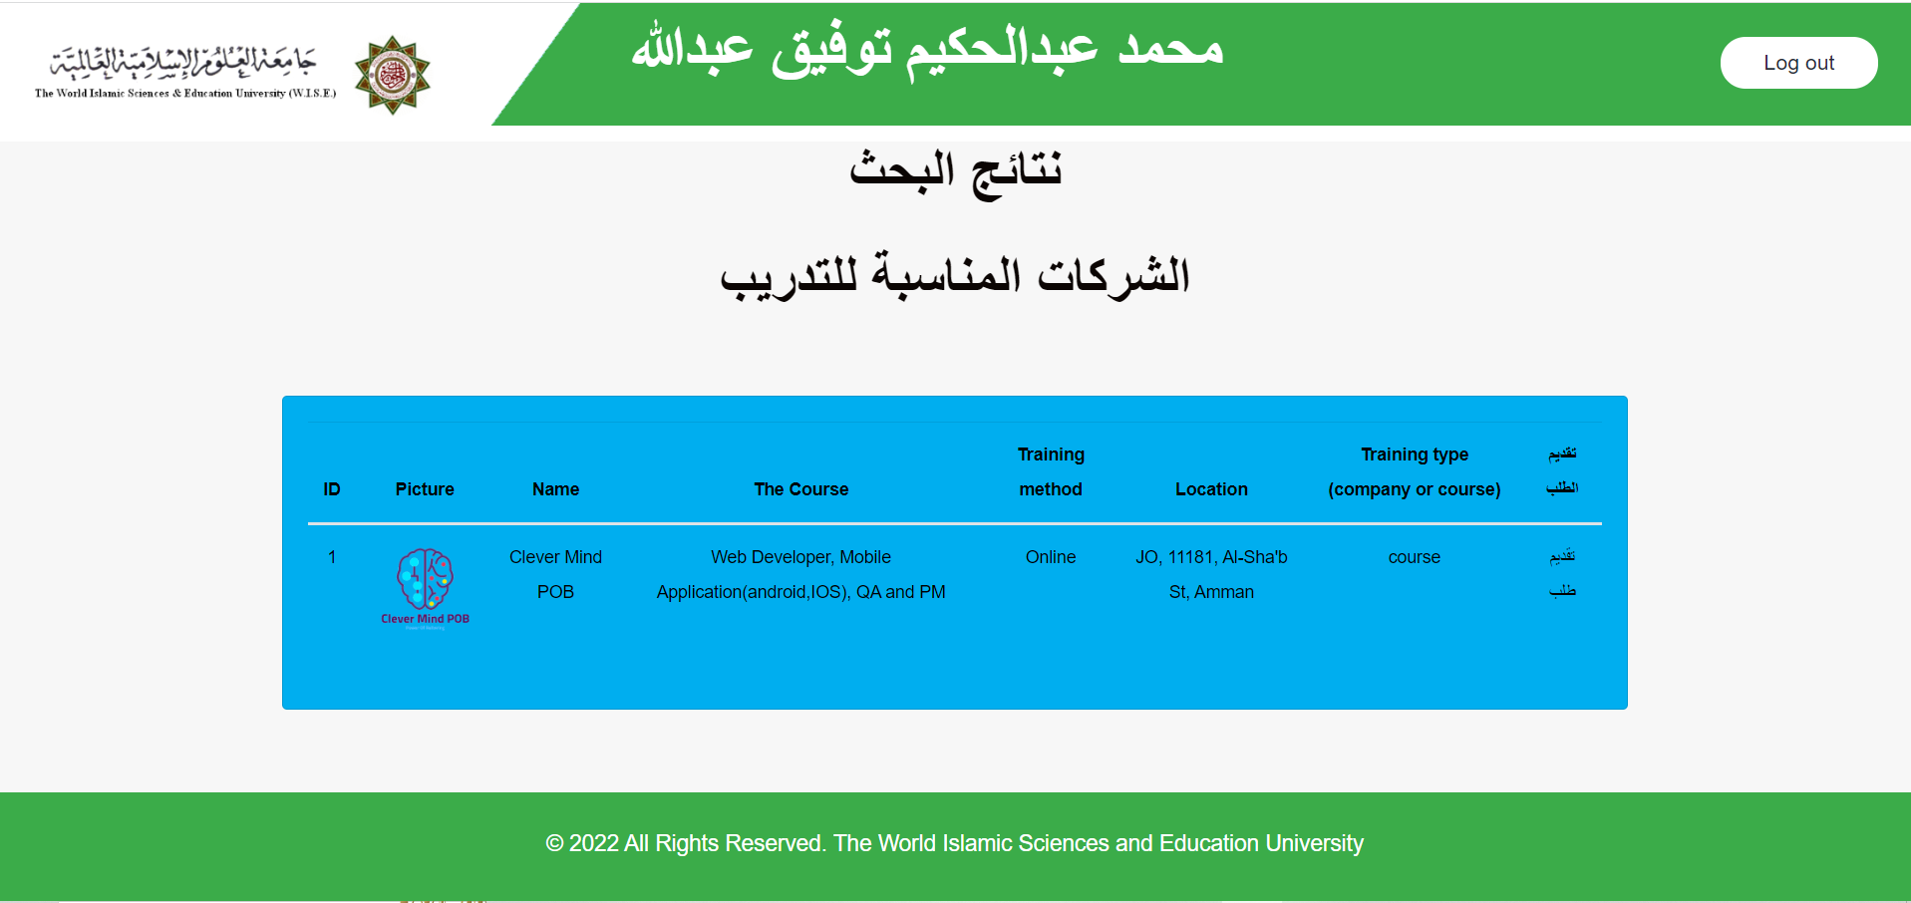

*Figure 15: Search using filter*

1-4. Submit a training request.

-After the student selects the company and the type of internship he wants, he presses the Submit Request button.

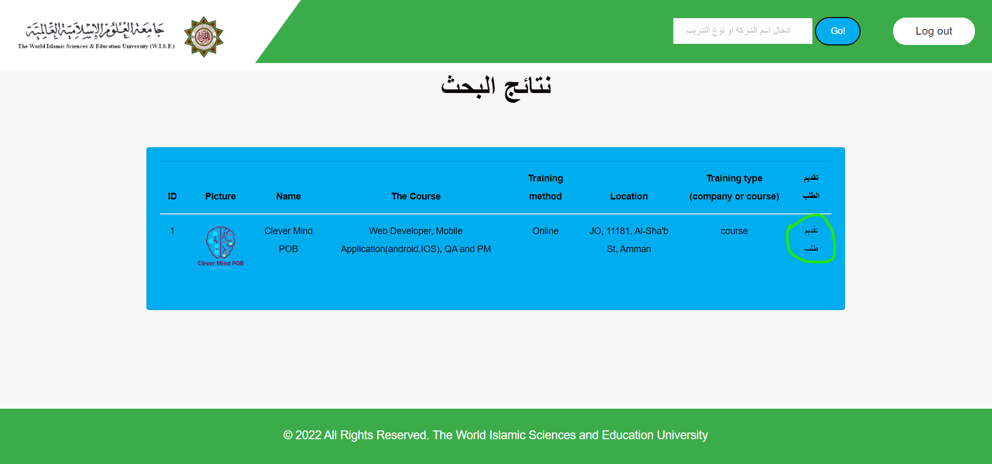

*Figure 16: Training Request*

- Where the student applies through the company's website, which provides a form to fill out the student's information, which is stored in the company's database of the company to be trained in.

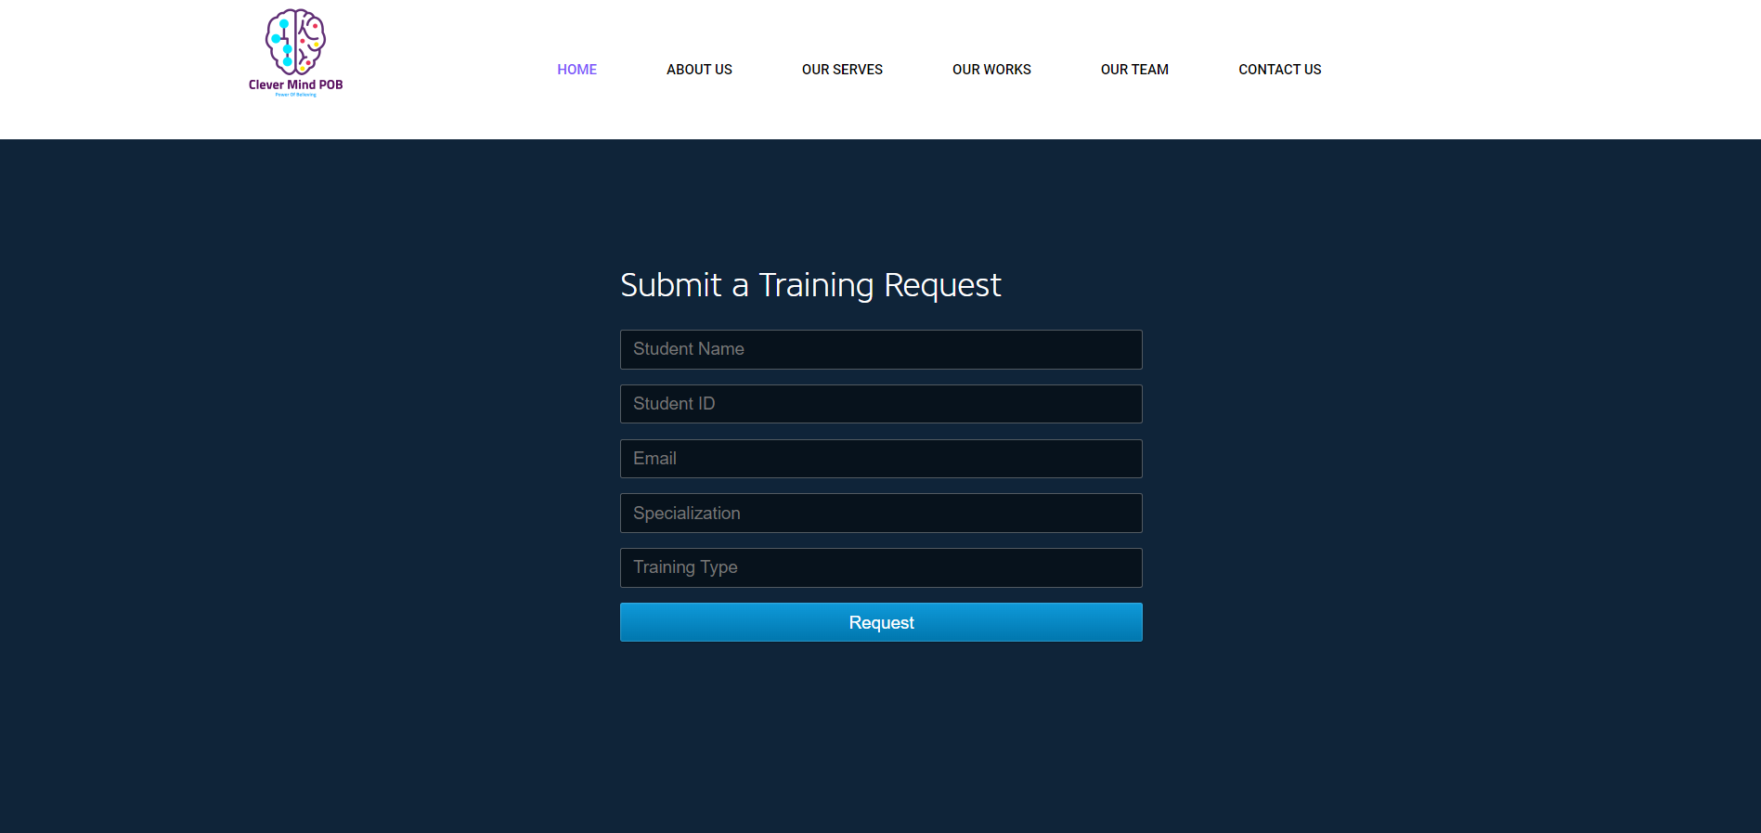

*Figure 17: Training Request 2*

- The student must enter all the required data to be able to apply.

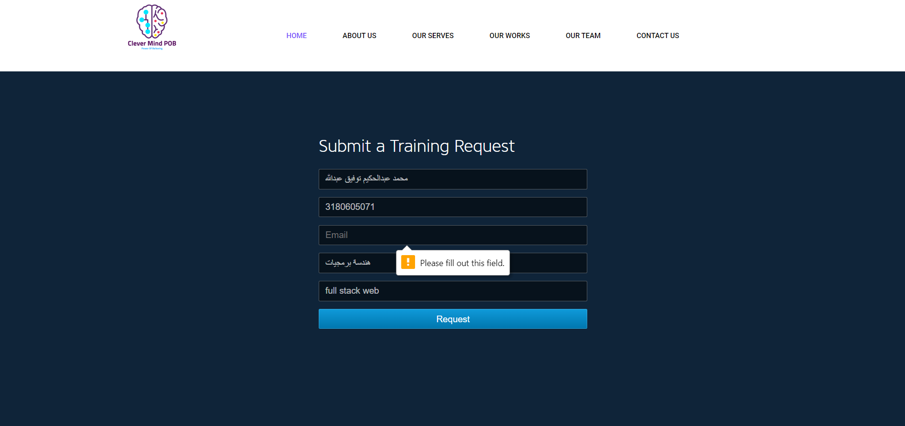

*Figure 18: Full all input*

-I built a dummy database representing companies where student data is stored.

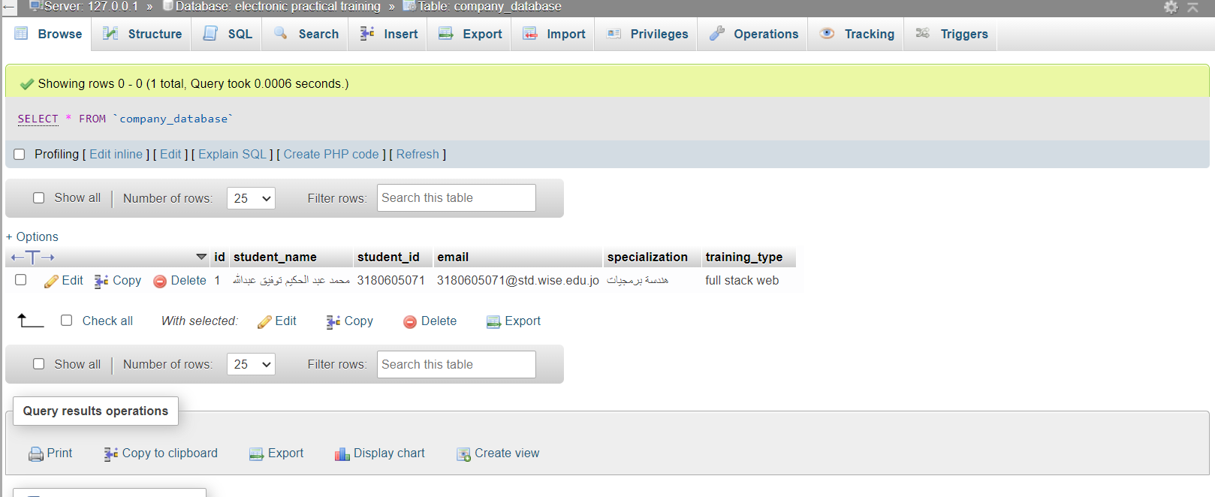

*Figure 19: Company Database*

1-5. Apply for admission.

-The student receives the application for admission from the company via e-mail, and then enters through the main page to (Send Approval No. 3), where he enters his data and the admission file in PDF format.

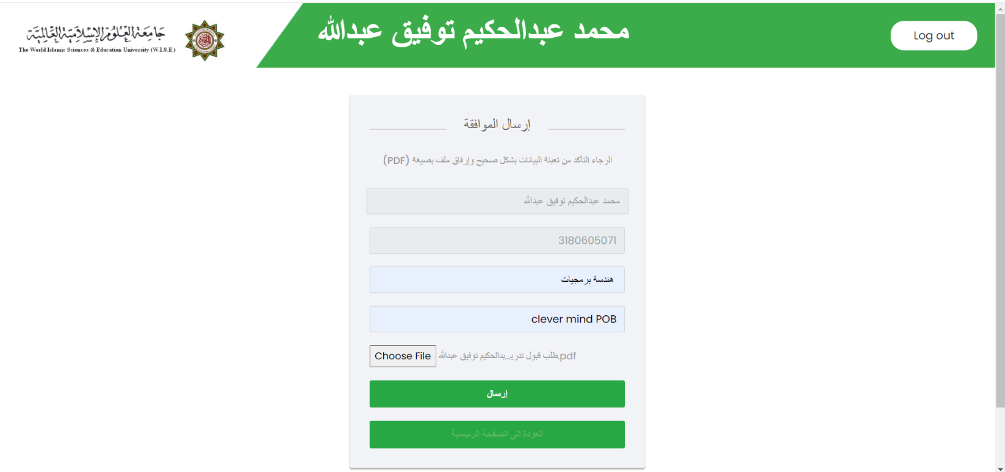

*Figure 20: Send Approval*

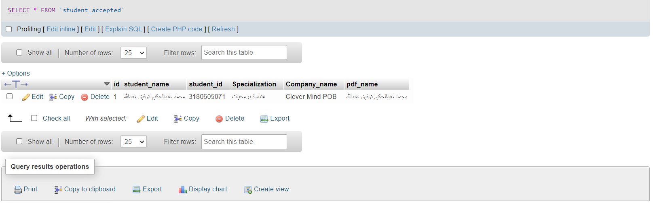*Figure 21: Students accept database*

1-6. Companies view

-The companies submit training offers to the university through a button that is inserted into a separate page where the company is required to abide by the university’s conditions and then enter all the required data.

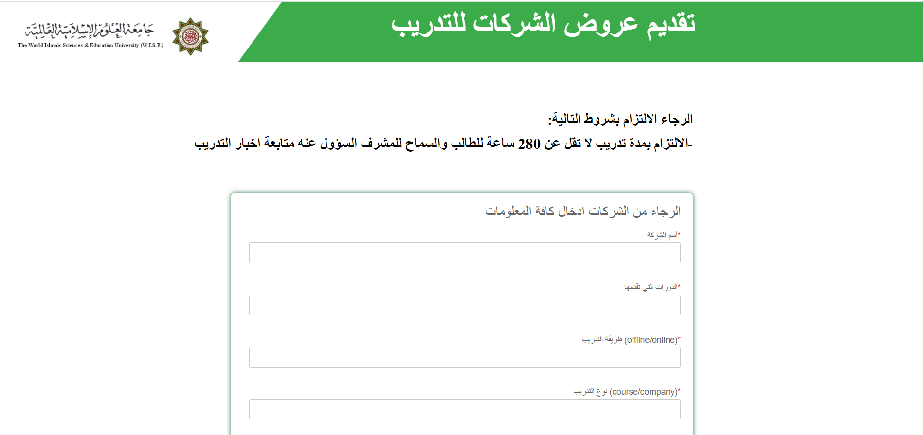

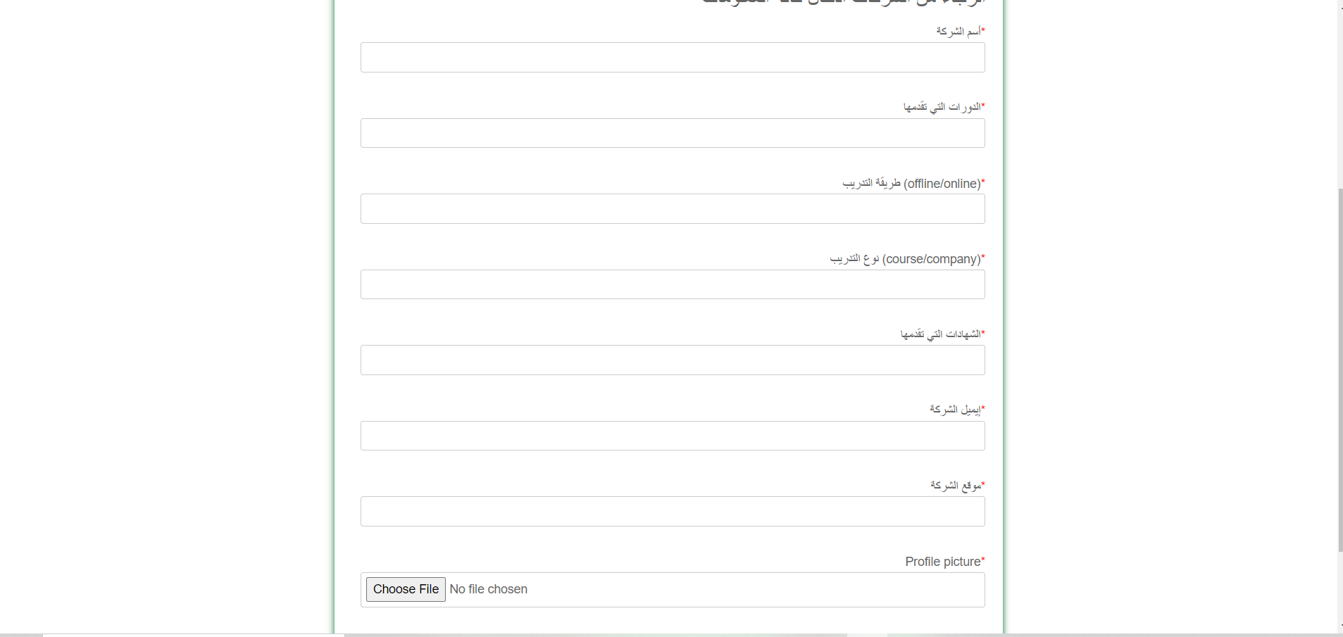

*Figure 22: Company offers*

1-7. Admin site.

-The responsible person at the university manages all the topics on the site, as he is responsible for receiving training offers from companies, approving or rejecting them, and communicating with companies via e-mail. Approval requests from the student and transferred to the training supervisors.

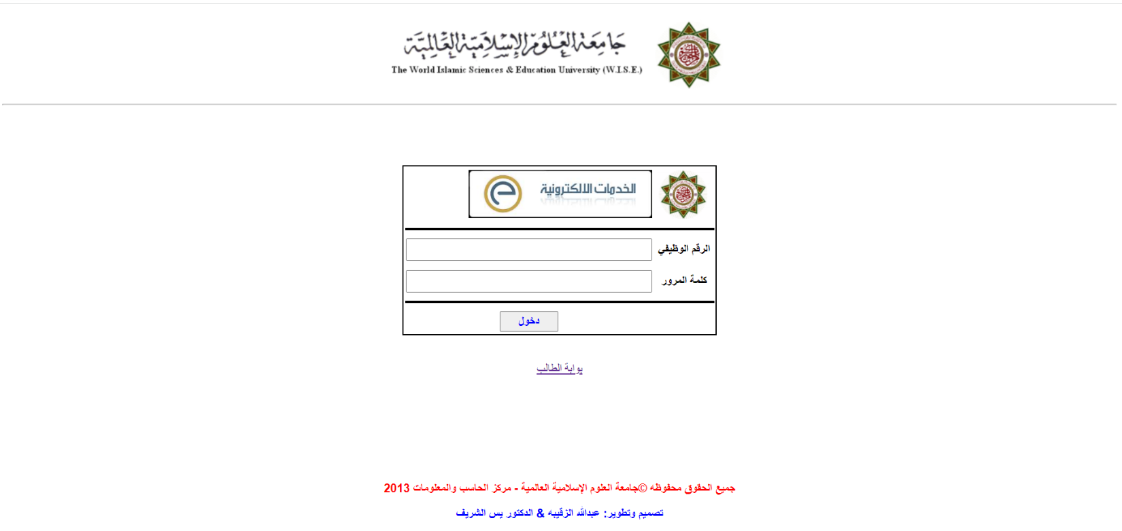

*Figure 23: Admin site 1.*

-After the company submits its offer to the university, it is presented first to the official’s site and then either approves or rejects the company, where the person responsible for approval is the dean of the college or his deputy, who then issues a decision either to approve or reject.

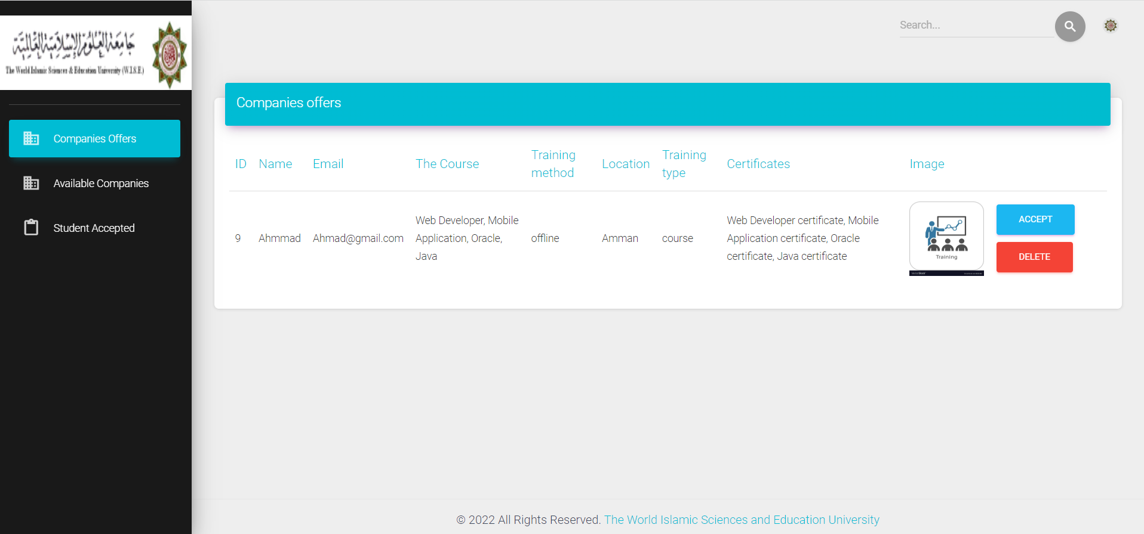*Figure 24: Company offers admin site.*

-After the responsible person approves the company, he is transferred to the (available companies) page, where it is presented to the student.

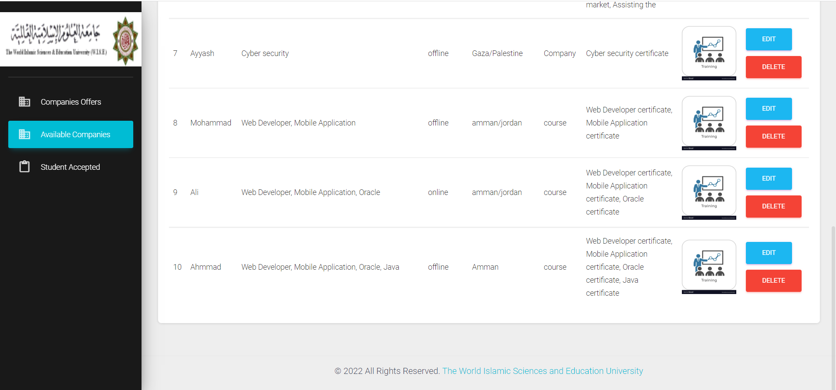

*Figure 24: Available company.*

-The responsible person can amend any company, as if an amendment arrives from the company to one of the information, the responsible person amends it.

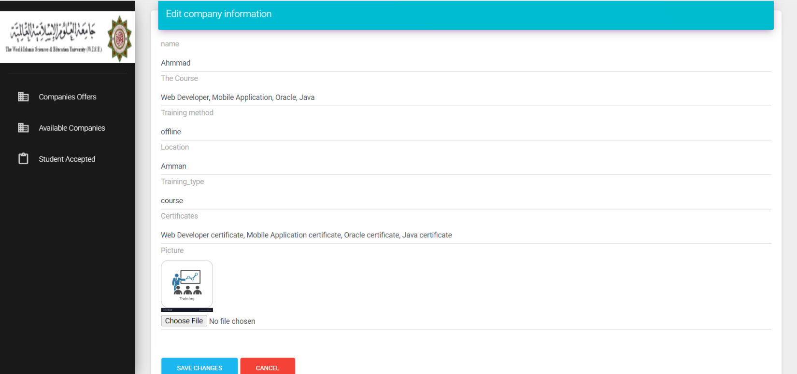*Figure 25: Edit the company.*

-In the third option on the official website page, all students who have sent an application for admission are displayed, and if there is any problem, he will communicate with them via e-mail.

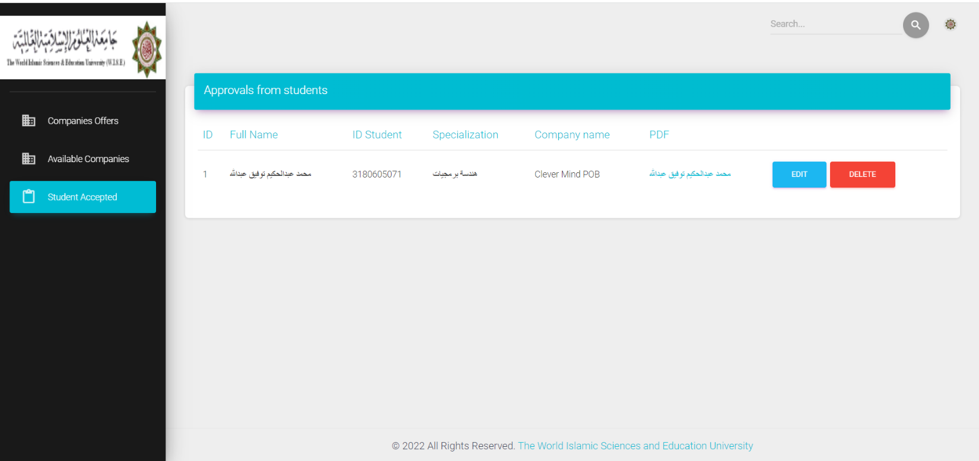

*Figure 26: Student acceptance.*

- The responsible person can modify the student’s data if any problem occurs or delete it if the student withdraws from the practical training course, where the responsible person contacts the company to inform them and withdraw the training from the student.

2. Integration Testing.

Here we can see one of the test cases that we implemented on the student login page to see if it works as intended with the database:

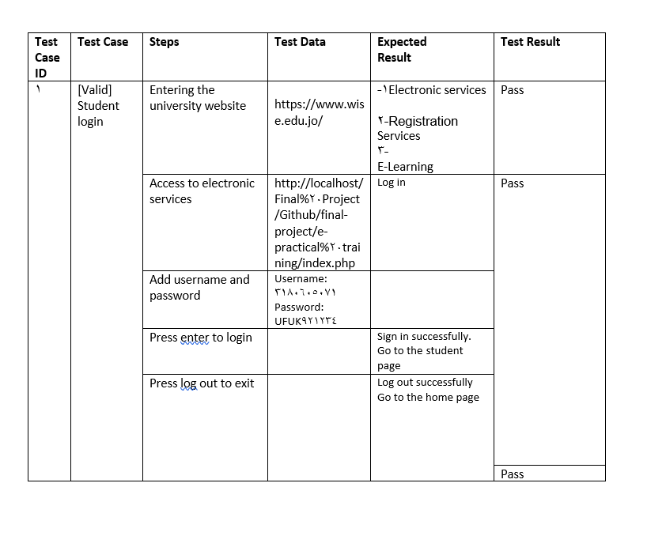

*Figure 27: A test case.*

And here we can see one of the bug reports for a bug that was discovered on the “Admin site” page:

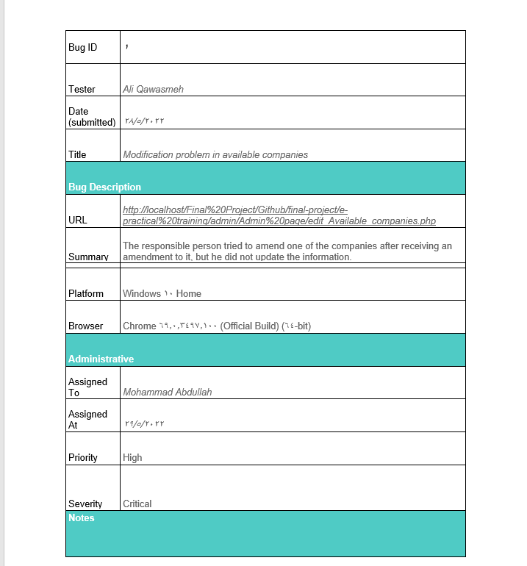

*Figure 28: Bug report.*

3. System Testing.

All intended functions work as expected to be after we tested them in the unit testing phase.

Below is the result of the survey that was sent to a sample of users to try out the practical e-training GUI:

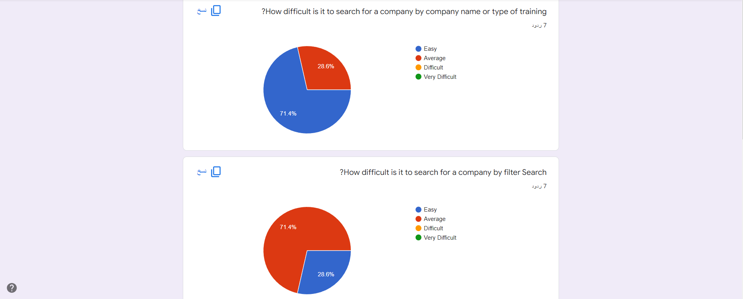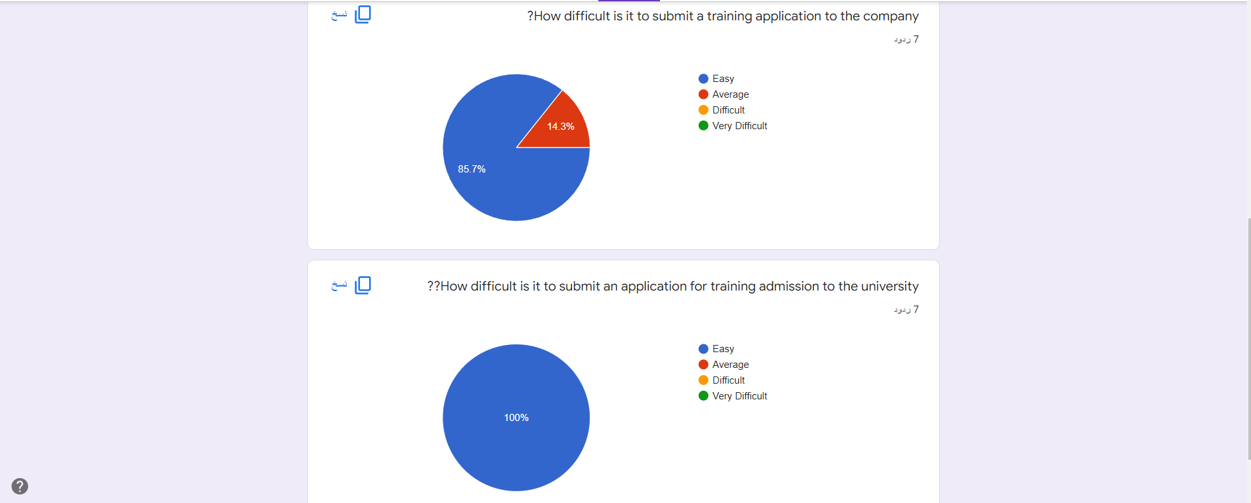

**Chapter 6: Conclusion**

1. Conclusion.

The site works as intended, where the student can choose the company he wants and the type of training he wants, submit an application to the company, and then send the admission file to the admin site.

2. Future Work

* Mobile App
* Chatting System
* Distance learning system
* personal site
* My favorite list

References:

[1] <https://www.forbes.com/sites/jonyounger/2019/09/14/surgeons-are-joining-the-freelance-revolution-meet-nash/?sh=1837801533e6>

[2] <https://www.youtube.com/c/thecharmefis>

[3] <https://www.goskills.com/Project-Management/Resources/When-to-use-agile-project-management>

[4] [https://iwconnect.com/agile-methodologies-scrum-vs-kanban-advantages-disadvantages/?fbclid=IwAR3cbVeN-573aPIqjCazWAxnsktdiaFu8tf4j8c6VcHkFIVb93Mv6T5A2mQ#:~:text=%20Some%20major%20advantages%20are%20listed%20here%3A%20,process%207%20Increased%20productivity%20and%20efficiency%20More%20](https://iwconnect.com/agile-methodologies-scrum-vs-kanban-advantages-disadvantages/?fbclid=IwAR3cbVeN-573aPIqjCazWAxnsktdiaFu8tf4j8c6VcHkFIVb93Mv6T5A2mQ%23:~:text=%20Some%20major%20advantages%20are%20listed%20here%3A%20,process%207%20Increased%20productivity%20and%20efficiency%20More%20)

[5] <https://www.w3schools.com/>

[6] <https://stackoverflow.com/>

Appendix:

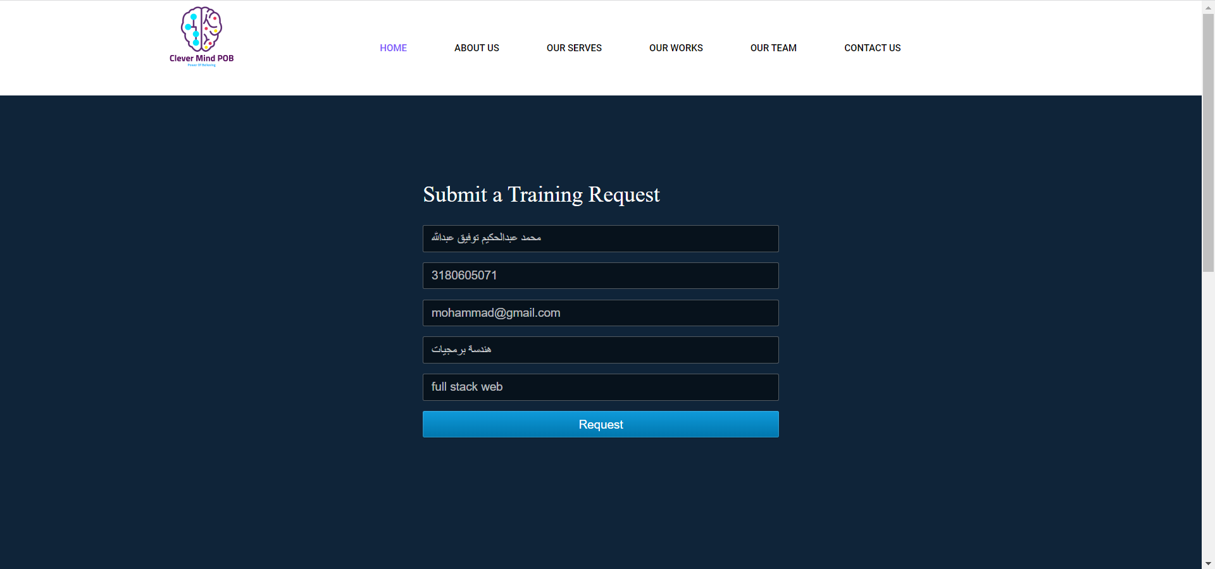

**\* On the home page there is a file of instructions where there is a full explanation of how the site works.**